Module 1. Carbohydrates
This section makes up about 13% of the test and is broken down into 3 subsections.
- Metabolism
  - Catabolic pathways (Glycolysis)
  - Anabolic pathways (Gluconeogenesis)
    - We’ll make glycogen a separate category and keep glycogenesis and glycogenolysis together.
- Chemistry
  - Structure
  - Properties
  - Function
- Nutritional Concepts
  - Food sources
  - Digestion

- METABOLISM
  - GLYCOLYSIS
    - Literally means “sugar breakdown”. Don’t forget that “-lysis” is breaking and “-genesis” is making. That gets important when all of your “gly-/glu-“ words are blending together.
    - Happens in the cytoplasm of all tissues. (Remember, you have to know where every process happens, both on the cellular level and the tissue level. Also, don’t forget that glycolysis is the reason that the “Most of the time” rule is “most of the time”, not “all of the time”. Most of the time, energy making processes happen in the mitochondria. Most of the time, the cytoplasm is for storage processes. However, since some tissues don’t have mitochondria, glycolysis is your way of making energy in the cytoplasm. This gets important for red blood cells and neurons, neither of which have mitochondria.
    - What’s the point – First step in breaking down carbs / glucose for making energy. For every process, you need to know the purpose of the process.
    - Glycolysis is an anaerobic process. That means that you don’t need oxygen to get from glucose to pyruvate. Whether oxygen is available to pyruvate determines the next steps, after glycolysis.
    - Here is the link to the glycolysis video review
      - https://youtu.be/NXXBr6ZUhEA
      - The diagram used in the video is the one that we used in class and that you might have used for your project.
    - Let’s quickly mention glucose transporters.
      - GLUT-1 – works in all cells, regulates basal uptake, even at low glucose levels
      - GLUT-2 – works in liver and pancreas, acts as a glucose sensor, increases glucose uptake in high glucose levels for storage. Also, regulates insulin release from the pancreas
      - GLUT-3 – most tissues
      - GLUT-4 – INSULIN-DEPENDENT, works in muscle, adipose tissue, heart, for storage (think “insulin equals storage”).
      - GLUT-5 – small-intestine, absorbs FRUCTOSE
    - The phosphofructokinase step (remember F-6-P to F-1,6-bp step) is the rate-limiting step.
    - The CORI CYCLE is a “do-over loop” that regenerates glucose. Remember, you don’t need oxygen to get from glucose to pyruvate. However, you need oxygen for the pyruvate to continue to ATP (think back to the “Big Picture”). The Cori Cycle, in the absence of sufficient oxygen, is a way of getting glucose back to “try again”.
      - Lactate dehydrogenase is the enzyme that converts pyruvate to lactate in the muscle, then converts lactate back to pyruvate in the liver (remember the liver “takes care of” all your tissues and “cleans up after” all your tissues).
  - GLUCONEOGENESIS
    - This is the process that makes glucose out of non-carbohydrate sources (i.e. de novo synthesis of glucose).
      - Typical non-carbohydrate sources are
        - Pyruvate – think Cori Cycle
        - Lactate – keep thinking Cori Cycle
        - Glycerol – think DHAP and triglycerides. We’ll come back to this.
        - Amino Acids – remember, we break down amino acids (transaminate) into molecules that you already know, some of which are molecules that you saw in glycolysis, which are also molecules of gluconeogenesis (except for oxaloacetate, which is only in gluconeogenesis).
      - The reversible reactions of glycolysis just reverse for gluconeogenesis, so don’t learn them twice.
        - Don’t forget that phosphoglycerate kinase is an enzyme of both processes. We tend to associate it with glycolysis because we make a big deal about it in glycolysis (the enzyme that catalyzes the first reaction of glycolysis in which ATP is formed. In gluconeogenesis, it just catalyzes one more reversible reaction.
      - If you’re ever not sure what is happening in a gluconeogenic reaction, just remember that, whatever is the worst deal for you energetically, is what is going to happen. That is, if you can lose an ATP or NADH, you will. If you’re not sure if you’re getting an ATP in a reaction, you’re not.
    - The conversion of F-1,6-bp to F-6-P is the rate-limiting step.
    - Happens in the liver, kidney and intestinal epithelium.
    - Don’t forget that you convert oxaloacetate to malate if AND ONLY if pyruvate starts out in the mitochondria. (M&M rule – 2 M’s or no M’s)
    - Here is the link to the gluconeogenesis video: https://youtu.be/L5PBLJdohig
      - The diagram used in the video is the one from class /the powerpoint. Its strength is that it makes the similarities to glycolysis very apparent. Remember that I cautioned you to use a diagram that clearly showed 2 molecules of pyruvate starting out and forming one glucose. It is too esy to forget that you have two of all of the initial molecules in the process.
    - It takes 4 “real” molecules of ATP to make one molecule of glucose by gluconeogenesis. However, it takes an additional 2 NADH and 2 GTP. Together, that all makes the equivalent (although the question won’t say “equivalent”) of 12 ATP. So, the strategy on the “how many ATP” question is to look for 4. If (and only if) 4 is not offered, then pick 12. The logic is that, by using the 2 NADH and 2 GTP, they won’t be there to use for making ATP so, in effect, they were part of your “cost”.
  - A couple more topics that might not necessarily fit here, but we’ll put them here anyway.
    - PENTOSE PHOSPHATE PATHWAY
      - Aka Hexose monophosphate shunt (common), Phosphogluconate Oxidative Pathway (less common)
      - Two distinct phases
        - Irreversible oxidative reactions
        - Reversible non-oxidative reactions
      - Purposes:
        - Makes NADH
          - For fatty acid synthesis, detoxification and protection from free radicals
        - Makes nucleotides / ribose for DNA and RNA
        - Processes 5-carbon (i.e. non-6-carbon sugars)
      - Rate-limiting enzyme is glucose-6-phosphate dehydrogenase
      - Transketolase moves 2 carbons. Transaldolase moves 3 carbons.
      - Here’s the video link: https://youtu.be/T9kxvyVFO8Q
    - FRUCTOSE AND GALACTOSE METABOLISM
      - Here’s the video link: https://youtu.be/-77fiE5bkDM
    - GLYCOGEN
      - Here’s the link for the video: https://youtu.be/41vvKKP2L9k (Krebs and Electron Transport are on the same video for now)
- CHEMISTRY
  - STRUCTURE
    - MONOSACCHARIDES
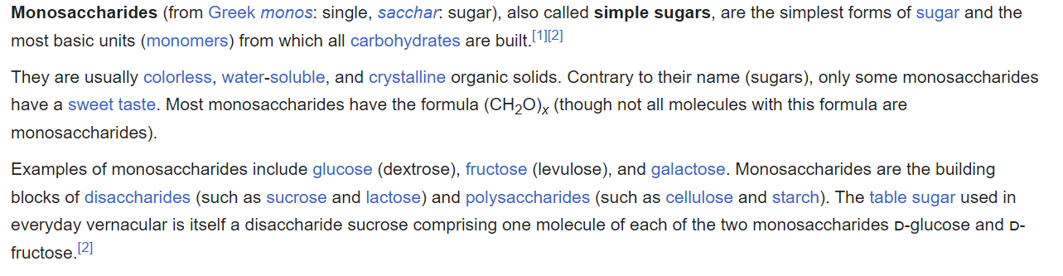
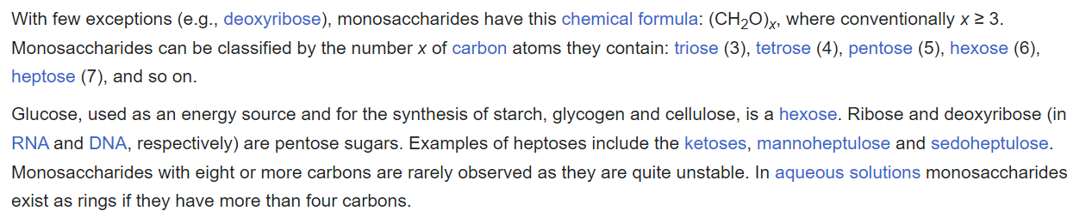
    - DISACCHARIDES
      - Sucrose is made up of glucose and fructose
      - Lactose is made up of glucose and galactose
      - Maltose is made up of glucose and glucose
      - Formed by glycosidic bonds
    - POLYSACCHARIDES
      - HOMOPOLYSACCHARIDE (same monosaccharide making them up)
        - GLYCOGEN – branched, alpha 1,4 bonds in linear part of molecule with branches connected by alpha 1,6 bonds.
          - Stored in liver and muscle, primarily (see video above)
          - Humans make it
        - STARCH – all glucose, plant molecule, made up of
          - Amylose – linear, alpha 1,4 bonds
          - Amylopectin- branched, same bonding as glycogen, but branches much further apart
          - Plants make it
        - CELLULOSE
          - BETA-1,4 bonds
          - We can’t digest it because of the beta bonds
          - Linear
          - Plants make this, too.
      - HETEROPOLYSACCHARIDES (made up of different polysaccharides)
        - Include GLYCOSAMINOGLYCANS (GAGs) – hold lots of water, think “snotty sugar”
        - Unbranched, linear polysaccharide made up of repeating disaccharides (one half is a uronic acid, other half is a modified sugar)
        - Common GAGs
          - CHONDROITIN 4-SULFATE
            - Most common
            - Extracellular matrix of connective tissue, cartilage, tendon and bone
          - DERMATAN SULFATE
            - Extracellular matrix of skin and blood vessels where it has an anti-thrombotic function
          - HEPARIN
            - Blood thinner / natural anticoagulant
            - Present in mast cells
          - HYALURONIC ACID
            - Synovial fluid
            - Found predominantly in umbilical cord, synovial fluid and vitreous humor of eye
    - GLYCOPROTEINS – protein and oligosaccharide
      - Proteins covalently attached to oligosaccharide
      - Think intercellular communication, cell surface receptors
      - Prothrombin, thrombin and fibrinogen play key roles in coagulation
      - Reproduction
      - Enzymes
      - Transport of vitamins and hormones
    - PROTEOGLYCANS – protein and GAG
      - Aka MUCOPOLYSACCHARIDES
      - Protein core with GAGs attached
  - FUNCTION
    - STRUCTURAL – such as plant cellulose
    - FUEL – energy stores
    - COMPONENTS OF NUCLEIC ACIDS (think ribose and deoxyribose)
    - CELL SURFACE STRUCTURE
      - Intercellular signaling and recognition
- NUTRITIONAL CONCEPTS
  - FOOD SOURCES
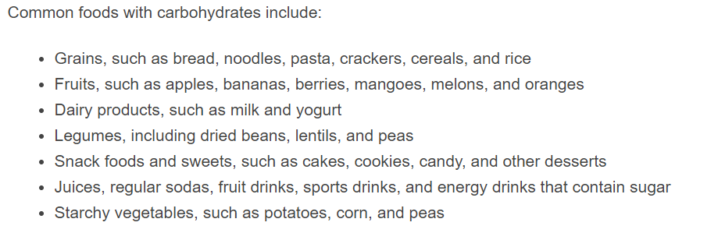
  - DIGESTION
    - Humans can only process sugars with the D-conformation, not L-conformation (don’t forget – opposite in amino acids)
    - We can’t digest cellulose because we lack cellulase, the enzyme that breaks it down.
    - SALIVARY AMYLASE
      - Breaks starch down into sugars
      - Present in the mouth
      - Inactivated by stomach acid /pH
    - PANCREATIC AMYLASE
      - Aka alpha amylase
      - Breaks longer chains down into tri- and disaccharides in the small intestine
      - Breaks alpha 1,4 bonds
    - TRISACCHARIDASES
      - Breaks down trisaccharides into di- and monosaccharides
    - DISACCHARIDASES
      - You guessed it – breaks down disaccharides into monosaccharides
    - SUCRASE – breaks down sucrose into glucose and fructose
    - LACTASE – breaks down lactose into glucose and galactose
    - DIGESTION VIDEO
      - This video has carbs, fats and proteins in one video.
      - Here’s the link: https://youtu.be/VVuVDuPSxmY

MISCELLANEOUS CARB STUFF
Just a few more things, but not sure where they fit in, so here you go…..
DIETARY FIBER
- Non-digestible plant material
- SOLUBLE
  - Fermented in GI to gas and short-chain fatty acids
  - Decreases motility in GI tract
  - Swells in stomach to make you feel full
  - Binds bile (cholesterol), TAGs, glucose and decreases absorption
- INSOLUBLE
  - Not fermented
  - Increases motility in GI tract
LET’S RE-VISIT NUTRITION FOR A MINUTE
- Carbohydrates have 4 cal/g
- RDA = 130 g/day
- Fiber RDA = 25 g/day (females) and 38 g/day (males)
- Normal blood glucose = 70-99 mg/dL
- These numbers have been used for standardized testing for years. Make sure you refer to Dr. Krabbe’s class for clinical numbers.
GLUCOSE TRANSPORT
SECONDARY ACTIVE TRANSPORT
- Uses sodium glucose transporters, SGLT-1 in small intestine and SGLT-2 in kidney
- Na/K ATPase pump
FACILITATE DIFFUSION
- Uses glucose transporters
- Remember GLUT-1 and 3 (most tissues) and GLUT-5 (small intestine, absorbs fructose) are INSULIN-INSENSITIVE
- GLUT-2 (liver, kidneys, pancreas, and intestine) and GLUT-4 (muscle and adipose) are INSULIN-SENSITIVE

